PATVIRTINTA
Klaipėdos miesto savivaldybės
tarybos 2019 m. kovo 28 d.
sprendimu Nr. T1-91
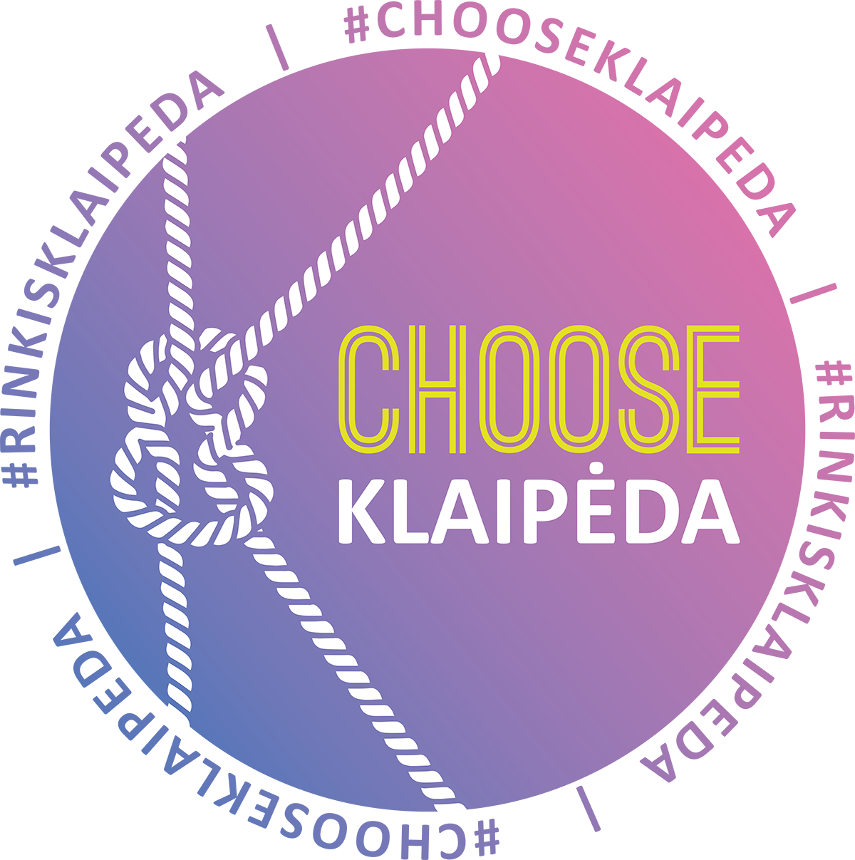
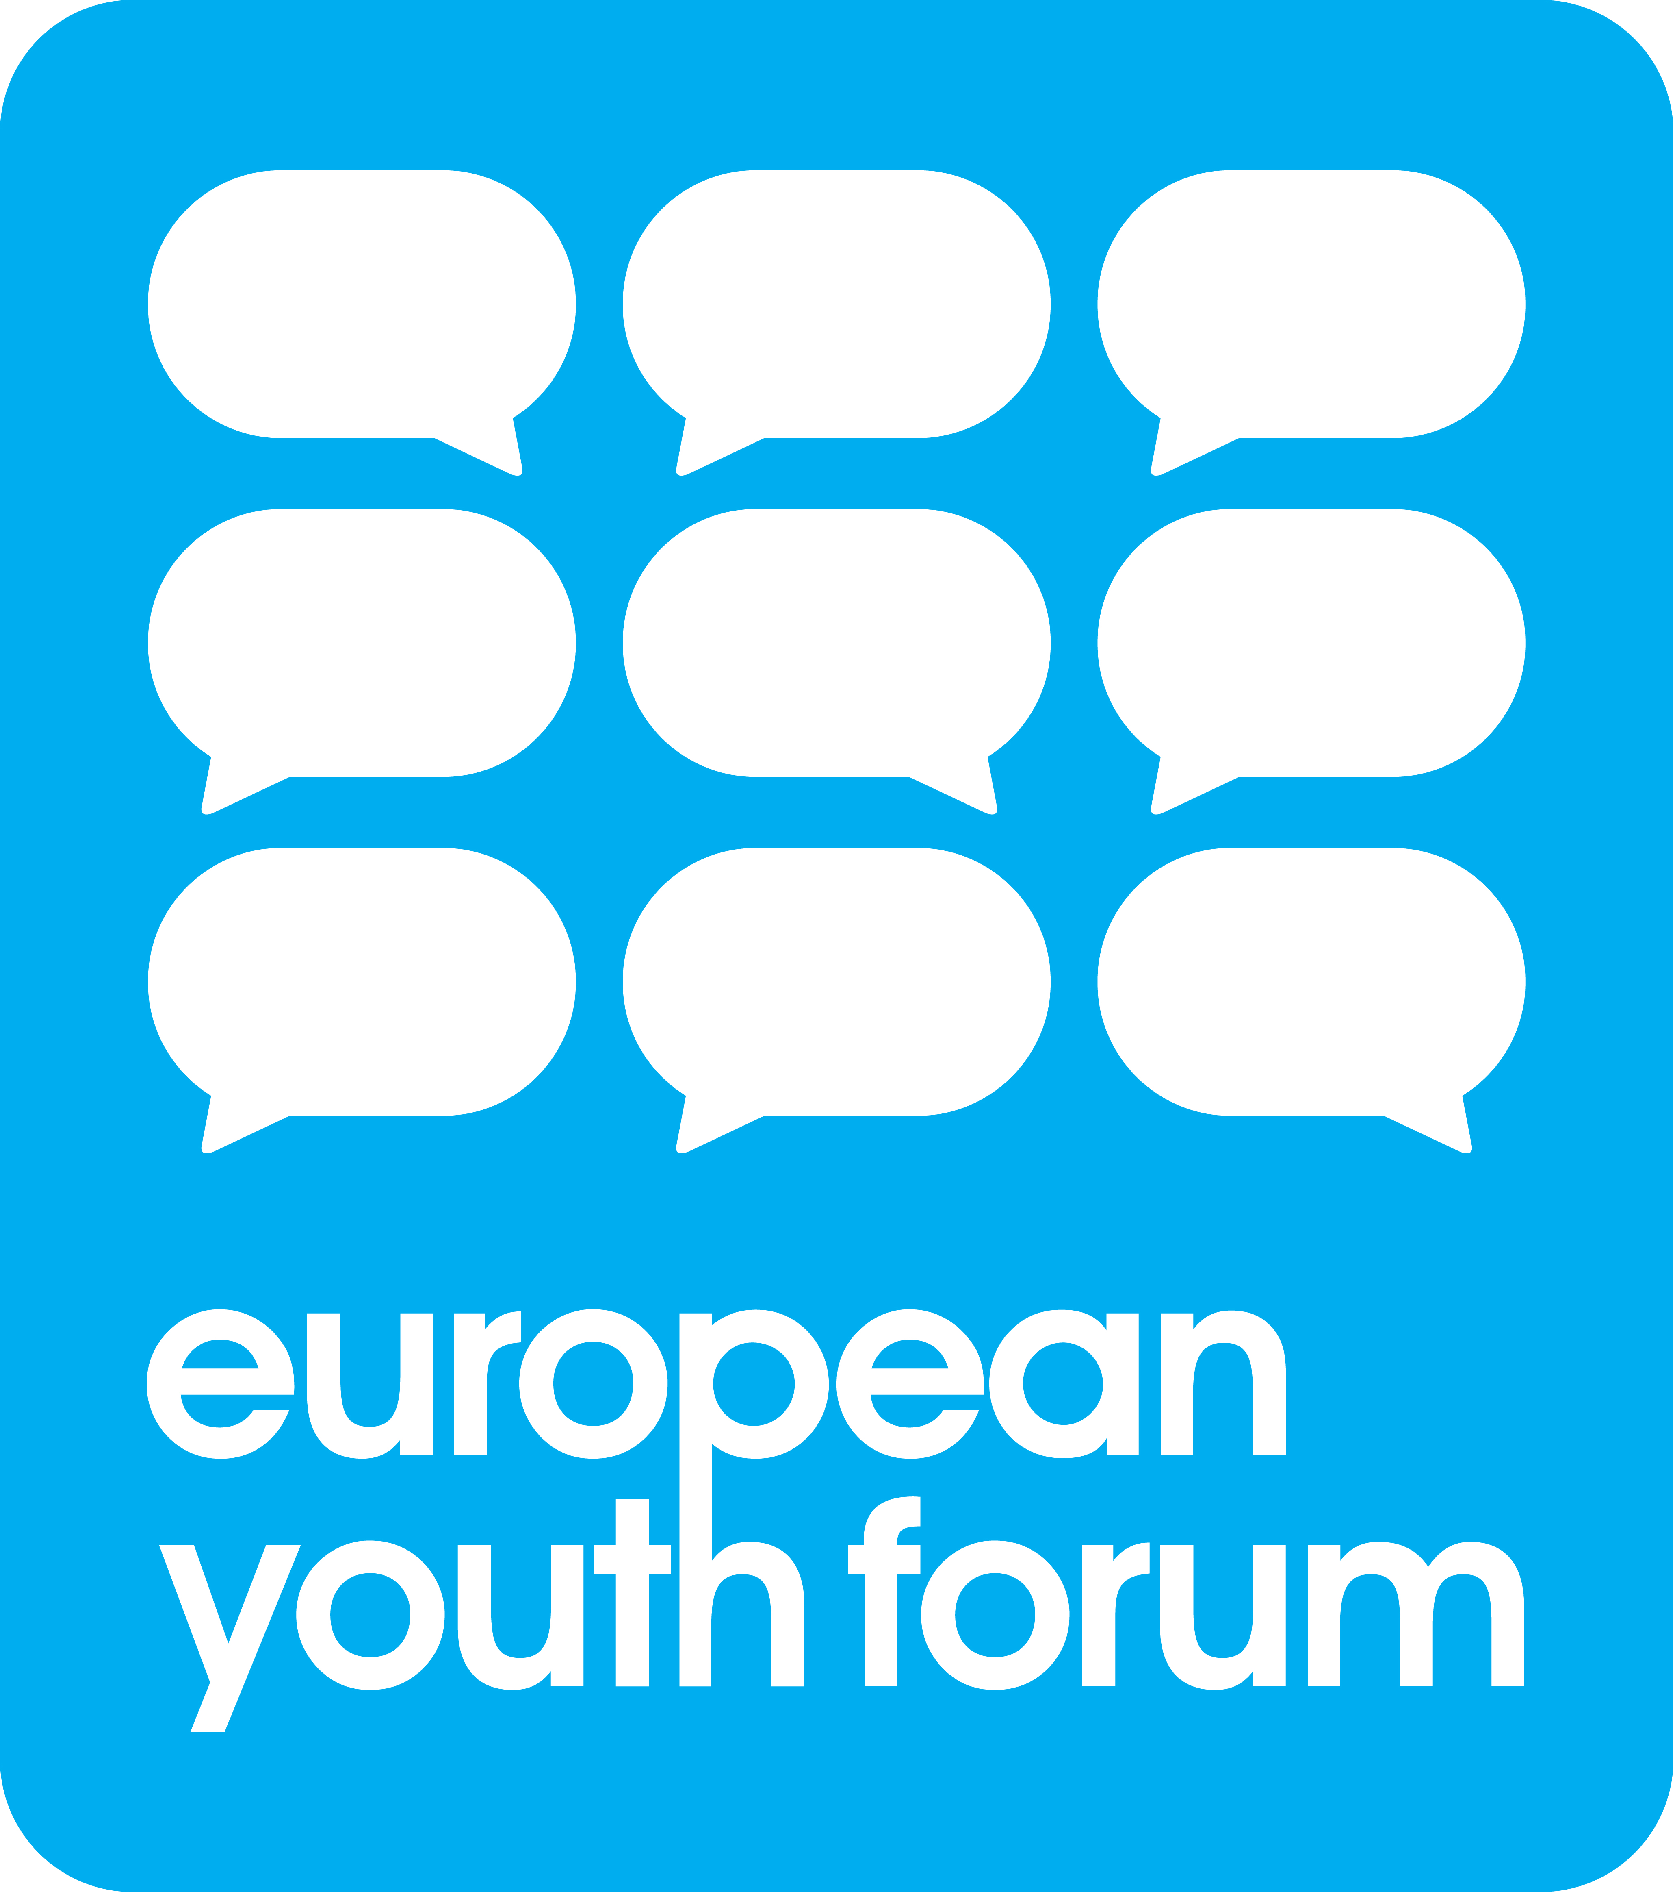

Cooperation Agreement

European Youth Capital 2021

This Cooperation Agreement, hereinafter referred to as the "Agreement" is made on _______ (date).
BETWEEN:
- European Youth Forum AISBL, an international not-profit association (“Association internationale sans but lucratif”) incorporated under the laws of Belgium, having its registered office in Belgium at 1000 Brussels, Rue de l’Industrie, 10 and registered with the Belgian Crossroads bank of companies (Banque-Carrefour des Entreprises) under number 0877.890.832 (hereinafter referred to as the "Forum")
Hereby legally represented by Ms Anna Widegren in its capacity of Secretary General ;
AND
- City of Klaipėda
Hereby legally represented by Vytautas Grubliauskas, in its capacity of Mayor of Klaipėda;
Hereafter referred to individually as a “Party” or collectively as the “Parties” for the purpose of establishing the cooperation arrangements between the Parties relating to the European Youth Capital 2021 (hereinafter referred to the "EYC 2021").

BACKGROUND
WHEREAS:

- The “European Youth Capital” (EYC) is a title awarded to a European municipality or group of municipalities for the period of one (1) year, during which it is given the chance to showcase, through a multi-faceted programme, its youth-related cultural, social, political and economic life and development.
- The EYC initiative encourages municipalities to both continue and expand the implementation of new ideas and innovative projects with regard to the active participation of young people in society, and seeks to present a role model for the further development of youth policies in other European municipalities.
- As promoter and coordinator of the EYC process, the Forum facilitates the work of the Jury and the selection process of the EYC. The Forum is the representative youth platform that gives legitimacy to the EYC project and is therefore interested in improving the EYC process for the future.
- At the European Capital Award Ceremony held on 21 November 2018 in Novi Sad, the City of Klaipėda has been awarded with the title "EYC 2021". In this respect, the City of Klaipėda will focus on creating an open, cooperative, youth friendliest city in the Baltic Sea Region and becoming the center of excellence for youth policy implementation.

Therefore, Parties now desire to enter in the herein described bilateral written agreement in order to agree and formalise the terms and conditions of the cooperation between the Forum and the City of Klaipėda as EYC 2021.

IT IS AGREE AS FOLLOWS:

Definitions and interpretation

In this Agreement, unless the context otherwise requires, the following definitions shall apply:

"Agreement" means the present agreement including any Annexes to it and any document in agreed form.

"Award" means the European Youth Capital title 2021.

"Award Ceremony" means the European Youth Capital Award Ceremony during which the Award is granted to the selected Short-Listed Candidate.

"Awarded City" means the Short-Listed Candidate awarded with the EYC title.

"Award Year" means the span of time beginning on the 1st of January and ending on the 31 December 2021 during which the City of Klaipėda has the right to use the title "European Youth Capital 2021".

"Candidate" means a Local Authority applying for EYC.

"COMEM" means the Council of the Members of the Forum.

"European Youth Capital" in short "EYC" means the title awarded to a Local Authority for a period of one (1) year during which it showcase its youth-related cultural, social, political and economic life and development.

"EYC 2021" means the City of Klaipėda.

"EYC 2021 Project" means the overall proposal of the City of Klaipėda as outlined in the Final Application submitted in the third application round.

"EYC 2021 Programme" means the different activities as set out in the third and/or last application form of the City of Klaipėda.

"EYC Terms and Conditions" means the standard terms and conditions for all European Youth Capital awards.

"EYC Policy Toolkit" means the collection of youth related policy documents available online under (https://www.youthforum.org/youthcapital-policy-toolkit) and aimed at guiding the Candidates in developing and making reference to policy implementation in their programmes .

"Extra-Delegates" mean the representatives delegated by the members of the Forum to a Statutory Meeting in addition to the Member Delegates.

"Final Application" means as the case maybe, either the improved final application form submitted in the third application round within the Third Application Deadline or the application from the second application round, if the Candidate does not send an improved final application form within the Third Application Deadline or if the improved final application form is received after the Third Application Deadline.

"Follow-up Period" the span of time beginning on 1st January 2022 and ending on 31st December 2023.

"Forum" means the European Youth Forum AISBL which is an international non-profit association under Belgian law with registered office at Rue de l’Industrie 10, 1000 Brussels, Belgium and registered at the Belgian Crossroads Bank of Enterprises (Banque-Carrefour des Enterprises) under number 0877.890.832.

"GA" means the General Assembly of the Forum.

"Guest" means all people invited by the Forum to participate in a Statutory Meeting.

"Local Authority" means a municipality or a group of municipalities located in a common geographical area.

"Member Delegates" means the representatives delegated by the members of the Forum to a Statutory meeting according to article A.1.2. of the Rules of Procedure of the Forum.

"Preparation Period" means the span of time beginning on the day after the signing of the Cooperation Agreement and preceding the Award Year.

"Short- Listed Candidates" means up to five (5) Candidates selected by the Jury after the online consultation following the first application round.

"Statutory Meeting" means either the Council of Members meeting or the General Assembly meeting of the Forum.

In this Agreement, unless the context otherwise requires:

Words in the singular include the plural and vice versa and words in one gender include any other gender;

A reference to a statute or a statutory provision includes any subordinate legislation made under it and any statute or statutory provision which modifies, consolidates, re-enacts or supersedes it whether such statute or statutory provision comes into force before or after the date of this Agreement ;

A reference to

any Party to this Agreement includes personal representatives, successors in title and permitted assigns ;

a “person” includes any individual, firm, body corporate, association or partnership, government or state (whether or not having a separate legal personality) ; and

clauses and annexes are to clauses of and annexes to this Agreement and references to paragraphs are references to paragraphs of the annex in which they appear.

General words shall not be given a restrictive meaning where they follow one or more specific terms indicating a particular category of act, matter or thing or where they are followed by examples. The words “including” and “in particular” (or similar) shall not limit the generality of any preceding words.

Subject of the Agreement

This Agreement aims to formalise the relationship between the Forum and the City of Klaipėda and their cooperation in (i) the preparation, implementation, evaluation of and the financial contribution of each Party to the EYC 2021 and the EYC 2021 Project including the EYC 2021 Programme (Annex I), (ii) the Statutory Meeting and the Award Ceremony (Annex II & Annex III).

The Parties set out hereunder the principles of their cooperation but agree and acknowledge that this Agreement shall not be construed as a services agreement under which a Party will pay any amount or raise invoices towards the other Parties.

EYC Terms and Conditions, Annexes and Order of precedence

The Parties agree and acknowledge that the EYC Terms and Conditions and all Annexes shall form an integral part of this Agreement and legally bind both Parties.

Unless otherwise provided in this Agreement, the clauses contained in the body of this Agreement shall have precedence over the clauses contained EYC Terms and Conditions and in the Annexes.

Benefits of the Award

The Award represents significant value to the City of Klaipėda which is given in the framework of the EYC 2021 title a unique opportunity to reap the following benefits:

Empowered and actively engaged youth that generates new ideas and meaningfully contributes to the development of their society and neighbouring areas, therefore, leads it to a better future ;

A gained momentum to create sustainable long term programmes and initiatives which will endure long after the EYC 2021;
- The attempts to gather additional public funding and new financial donors for youth related initiatives will be significantly easier;
- The city is given a chance to showcase its youth related issues on a European scale and thus will be spotlighted by a variety of media recognizing it as Europe’s most progressive in youth related cultural, social, economic and political life development;
- EYC 2021 will also be established as a city for international and European meetings presenting it as the logical place to host any kind of large-scale conference related to youth. Thus it will benefit local tourism and local economy;
- Increasing visibility and popularity for politicians and policy makers as a result of a number of international young people and young leaders as well as politicians who will visit the EYC 2021.

Rights and obligations of the Parties

General

In addition to the rights and obligations that they have towards any Third Party involved in the EYC 2021, the Parties will have the rights and obligations towards each other under this Agreement as further defined in the clauses hereunder and in the Annexes.

The Parties agree to use their best efforts, to act in good faith and cooperate to ensure the effective performance and operation of the EYC 2021 Project including the EYC 2021 Programme.

EYC – Governance structure
In order to allow efficient cooperation and implementation between the Forum as promoter of the EYC Project and the City of Klaipėda as EYC 2021, the Parties agree on the following governance structure in order to allow effective management of all preparation, implementation and evaluation process of the EYC 2021.

Coordination meetings

In order to allow a continuing development and a successful implementation of the EYC 2021 Project the Parties agree to hold coordination meetings on a regular basis and with the following minimum frequency:

at least one (1) coordination meeting in the Preparation Period;

at least two (2) coordination meetings in the Award Year, and

at least one (1) coordination meeting during the Follow-up Period.

The coordination meetings will be chaired by the Forum in cooperation with the National Youth Council.

The coordination meetings aim at:

reviewing and evaluating past processes;

setting an agenda for upcoming processes;

monitoring the current activities in order to ensure the successful implementation of the EYC 2021 Project including the EYC 2021 Programme.

Technical Office

The technical office for the implementation of the EYC 2021Project is composed as follows:

One (1) staff member of the secretariat of the Forum dedicating part of his/her time to coordinating the EYC 2021 Project on the European level.

One (1) team member of the EYC 2021 having the status of a “European Liaison Officer”.

The technical office has the following mission:

collaborate to facilitate and develop the framework of the EYC 2021 Project;

ensure the cooperation between the Parties within the European dimension of the EYC X2021 Programme

focus on building European partnerships, on raising the European profile and mobilising resources in favor of EYC 2021.

Local bodies

The EYC 2021 will establish Local bodies that will guide and monitor the EYC 2021 Project on the local level of the City of Klaipėda.

Implementation EYC 2021 Project

The City of Klaipėda shall undertake towards the Forum to implement the EYC 2021 Project. In this respect the City of Klaipėda acknowledges that it is bound by the specific activities and actions under the EYC 2021 Programme as set out in Final Application submitted in compliance with the EYC Terms and Conditions.

Forum’s Statutory Meeting

Without prejudice to article 6.1. of this Agreement, the City of Klaipėda commits, in cooperation with the Forum, to host and organise the Forum’s Statutory Meeting in the City of Klaipėda in 2020 as outlined in the explanatory notes "How to organise a General Assembly & an Award Ceremony ?" in Annex II and “How to organise a Council of Members & an Award Ceremony? “ in Annex III.

The participants of the Statutory Meeting are the Member Delegates, the Extra-Delegates, the Guests, the members of the Board and the staff of the Forum.

The City of Klaipėda contribution to the hosting and organisation of the Forum's Statutory Meeting includes the following:

Local accommodation and preparations for the technical items such as board and lodging, meeting rooms, food and drinks for the meeting and other, like local transportation and, in general, provide the requirements as outlined in the explanatory notes "How to organise a General Assembly & an Award Ceremony? " in Annex II and “How to organize a Council of Members & an Award Ceremony?” in Annex III;

Invite the local and national authorities (exact people and time to be agreed with the Forum's Secretary General);

The Forums contribution to the organization of the Forum's Statutory Meeting includes the following:

Promoting the City of Klaipėda as winner of the EYC 2021 through the Forum's communication channels;

Providing space for the City of Klaipėda to showcase their EYC 2021 related activities;

Travel for the Member Delegates, Extra Delegates, the Guests, the members of the Board and the staff of the Forum attending the Statutory Meeting.

Award Ceremony

Without prejudice to article 6.1. and 7 of this Agreement, both the City of Klaipėda and the Forum commit, in close cooperation, to host and organise the Award Ceremony of the EYC 2023 in 2020 in the City of Klaipėda as outlined in the explanatory notes "How to organise a General Assembly & an Award Ceremony ?" in Annex II and “How to organise a Council of Members & an Award Ceremony? “ in Annex III.

The participants of the Award Ceremony are the Member Delegates, the Extra-Delegates, the Guests and the Guests invited by the City of Klaipėda, the members of the Board and the staff of the Forum.

The Award Ceremony programme is developed in close cooperation between the Parties and shall ensure the sufficient timeframe for the Short-Listed Candidates of the EYC 2023 to present their application. The programme of the Award Ceremony must be jointly finalized not later than November 1st 2020.

The City of Klaipėda contribution to the hosting and organisation of the Award Ceremony includes the following:

Local accommodation and preparations for the technical items such as event venue, moderation and interpretation (if applicable), audio, visual needs, catering and other as outlined in the explanatory notes "How to organise a General Assembly & an Award Ceremony ? " in Annex II and “How to organise a Council of Members & an Award Ceremony? “ in Annex III.

The Forums contribution to the organization of the Award Ceremony includes the following

Promoting the City of Klaipėda as winner of the EYC 2021 through the Forum's communication channels;

Travel for the Member Delegates, Extra Delegates, the Guests, the members of the Board and the staff of the Forum attending the Statutory Meeting meeting;

The application fee collected for the European Youth Capital 2023 competition.

Communication, promotion and marketing

The visibility of the EYC will have to be ensured at all levels by the communication of the activities done at the local level, as example of good practice for other local realities as well as for the European level. One of the outcomes of the EYC is to connect the youth policy fields at local, national and European level drawing the attention for the common challenges regarding youth policy and youth participation in all dimensions.

The City of Klaipėda agrees that the Forum has non-exclusive permission, with the right to sublicense to sponsor(s), news and press agencies, journalists and other media professionals, to use the Final Application's content (except information that the City of Klaipėda expressly marked as "confidential") and/or the city of Klaipėda name, image and audio and/or visual recordings of the City of Klaipėda in any non-commercial publicity with due credit. End usage may include articles in newspapers/magazines/websites/social media posts/blogs; printed material or on-screen visuals at the Award Ceremony and presentation related to the EYC.

The EYC 2021 logo and graphic images can be freely developed by the City of Klaipėda;

The City of Klaipėda commits to use the general “European Youth Capital” brand.

The “European Youth Capital” brand will be displayed in the communication of the EYC 2021. The “European Youth Capital” brand will also be promoted on the website of the EYC 2021, as well as disseminated as widely as possible also through other associated initiatives.

Communication actions on key activities and visibility events should be discussed in the technical office and jointly taken care of to ensure that the image of the EYC 2021 is well echoed all over Europe.
Moreover, a periodic update on the main activities organised in the framework of the EYC 2021 and other contributions from the EYC 2021 will be featured on the Forum’s website. Which content is published in the newsfeeds of the European Youth Capital is to be defined between the Parties while implementing EYC 2021 communication plan.

The Forum will act as multiplier through its Member Organisations and its usual communication channels, working in cooperation with the EYC 2021 in developing common messages in line with the Forum’s policies.

Finances

Whenever financial means for common activities of the Parties in the framework of the EYC Project 2021 are necessary, the Parties shall agree jointly on the way of acquiring these funds.

The Parties agree to share the costs of the Statutory Meeting and the Award Ceremony as follows:

The City of Klaipėda shall bear and pay directly to the relevant service providers all local costs linked to the organisation of the Statutory Meeting and the Award Ceremony including but not limited to accommodation of all Member Delegates, Guests, local transport services, venue and meeting rooms, lightening, stage design, decoration, sound and video, speaker and special guests, entertainment.

The Forum shall cover and pay directly to the relevant service providers (i) the travel costs for the Member Delegates and Guests attending the Statutory Meeting and the Award Ceremony as well as (ii) all travel accommodation and other costs for the Extra Delegates attending the Statutory Meeting and the Award Ceremony.

The City of Klaipėda commits to a total financial contribution in the organization of the Forum's Statutory Meeting and the Award Ceremony to a minimum amount of 70 000 EUR.

Beside the agreed upon technical support and cost share payment(s) stipulated in article 10.2. of this Agreement, the Forum has no other financial obligations.

Suspension and revocation of the Award

The Forum reserves the right to suspend or terminate this Agreement for breach of any of the conditions set out in article 15.1 of the EYC Terms and Conditions and/or the terms and conditions of this Agreement. In case of termination, the Award and all privileges and benefits connected thereto, will be revoked.

The suspension process is the following:

Where the Forum has, upon inspection found or has reason(s) to suspect that the City of Klaipėda has committed any breach of the conditions set out in article 15.1. of the EYC Terms and Conditions, or has breached this Agreement, the Forum shall give Notice of Non-Conformity by registered mail and e-mail with returned receipt requested. Upon such notice, the Forum shall give the City of Klaipėda thirty (30) calendar days for rectification.

In the event of failure of rectification within the given deadline, the Award shall be suspended with immediate effect resulting in temporary stop of any communication and activities linked to the EYC 2021 title. The Forum shall notify the City of Klaipėda by registered mail and e-mail with returned receipt requested, the reasons for and conditions of the suspension, the appropriate corrective actions required, and the deadline for full completion of these appropriate corrective actions (the "Notice of Suspension").

Suspension of the Award shall be terminated by the Forum upon resolution of the initial cause of non-conformity or full completion of the appropriate corrective actions within the deadline set out in the Notice of Suspension.

Suspension shall proceed to termination of this Agreement (and therefore to definitive revocation of the Award and all privileges and benefits connected thereto), if the corrective actions required are not met or resolved by the deadline given in the Notice of Suspension.
Following termination of this Agreement the City of Klaipėda agrees to immediately destroy or to stop any communication by any media whatsoever containing any materials bearing the EYC 2021 brand and logo.

In the event that the City of Klaipėda breaches any of its obligations under article 15.1. EYC Terms and Conditions and/or under this Agreement, the Forum will have the right, without any further action or formality being required, to impose the payment of an immediately due and payable penalty of EUR 50000 (fifty thousand euro) for each such breach and of a periodic penalty payment of EUR 2000 (two thousand euro) for each day such breach continues, without the Forum having to prove any loss or damage, and without prejudice to the right of the Forum to claim full indemnification of its or third parties damages according to article 15.2. of the EYC Terms and Conditions.

Follow up on the EYC 2021

The EYC 2021 commits to present an evaluation report of the preparation phase and the implementation of the EYC 2021 outlining the achievements and challenges in different areas based on the Evaluation Report Template provided by the Forum.

The evaluation report must be submitted on December 2022 at the latest.

Without prejudice to article 15.2 of the EYC Terms and Conditions, failure to submit a satisfactory report within the above mentioned deadlines can result in the Award being revoked.

Duration

The cooperation between the Parties under this Agreement will take place between 01.01.2019 - 01.01.2024.

Coordinators and contact persons

The coordinator for the EYC 2021 Project as a whole on behalf of the city of Klaipėda is and his successor(s).

The coordinator for the EYC 2021 Project on behalf of the Forum is Ms Anna Widegren, Secretary General and her successor(s).

The coordinator for the General Assembly meeting and for the Awarded Ceremony on behalf of the City of Klaipėda is Aistė Andruškevičiūtė.

The coordinators for Statutory Meeting and for the Awarded Ceremony on behalf of the Forum are Ms Estefania Asorey, Statutory Meeting Coordinator, and Ms Rita Jonusaite, Policy Officer coordinating the EYC 2021 Project on the European level.

No partnership or agency

Nothing in this Agreement is intended to or shall operate to create a partnership or joint venture between the Parties, or to authorise either Party to act as agent for the other and neither Party shall have authority to act in the name of or on behalf of the other, or to enter into any commitment or make any representation or warranty or otherwise bind the other in any way.

Notice

Any notice to be given to a Party under this Agreement shall be in writing signed by or on behalf of the Party giving it, and shall be delivered personally, or sent by recorded delivery (or international equivalent, where required, with a copy per e-mail, to the address of the Party set out on page 2 of this Agreement. Either Party may, by a notice given in accordance with this clause, change its address for the purposes of this clause.

Severance

If any court or competent authority finds that any provision of this Agreement (or part of any provision) is invalid, illegal or unenforceable, that provision (or part) shall, to the extent required, be deemed to be deleted, and the validity and enforceability of the other provisions of this Agreement shall not be affected.

If any invalid, unenforceable or illegal provision of this Agreement would be valid, enforceable and legal if some part of it were deleted, the Parties shall negotiate in good faith to amend such provision such that, as amended, it is legal, valid and enforceable, and, to the greatest extent possible, achieves the Parties' original commercial intention.

Amendment

No alleged amendment of this Agreement shall be valid unless it is in writing (which excludes email) and signed by or on behalf of each Party.

Waiver

No failure or delay by a Party to enforce or exercise any right or remedy under this Agreement or by law shall be deemed to be a waiver of that or any other right or remedy, nor shall it operate so as to bar the enforcement or exercise of that or any other right or remedy at any time subsequently. Any waiver of any breach of this Agreement shall not be deemed to be a waiver of any subsequent breach.

Entire agreement

This Agreement constitutes the entire agreement and understanding of the Parties with respect to the subject matter of this Agreement and supersedes any prior agreements, representations, understandings or arrangements between the Parties (oral or written) in relation to such subject matter.

In case of translating this Agreement to Lithuanian language, the English version of this Agreement is the legally binding one

Governing law and jurisdiction

This Agreement and any dispute or claim (whether contractual or non-contractual)arising out of or in connection with it, its subject matter or formation shall be governed by and construed in accordance with the laws of Belgium, to the exclusion of the provisions on conflict of law.

Each Party irrevocably agrees that the courts of the judicial district of Brussels, Belgium shall have exclusive jurisdiction to settle any dispute or claim (whether contractual or non-contractual) concerning the validity, interpretation, enforcement, performance and termination of this Agreements and its Annexes.
Done in XXX, on XXX, in two (2) originals. Each Party acknowledges receipt of its own original.

European Youth Forum AISBL, represented by:
WIDEGREN Anna
Secretary General

City of Klaipėda, represented by:
GRUBLIAUSKAS Vytautas
Mayor of Klaipėda

Annexes :
Annex I EYC 2021 Project including the EYC 2021 Programme
Annex II How to organise a General Assembly & an Award Ceremony?
Annex III How to organise a Council of Members & an Award Ceremony?

