How to organise a Council of Members (COMEM)
&
an Award Ceremony

European Youth Forum

TABLE OF CONTENTS

Introductory notes and Timeline………………………………….3 - 5

Location…………………………………………………………………5

Hotel…………………………………………………………………….5
Rooms
Meals
Disabled Persons

Meeting Facilities………………………………………………….6 - 10
Plenary Room
Working-Groups Rooms
Technical Support
Interpretation Equipment
Sign Language and / or Speech to text translation
Secretariat room / Board room / Info desk

Non-smoking policy……………………………………………………10

Environmental policy…………………………………………………..10

Travel Arrangements…………………………………………………..10
Visas
Flights
Local Transportation (Airport-Hotel) Volunteers

Co-ordination…………………………………………………………..10

General Issues………………………………………………………. 10

Social Program……………………………………………………… 10
Saturday Evening
European Youth Capital Award Ceremony………………………11-13

What is the Council of Members?

According to the European Youth Forum (the Forum) Statutes, the Council of Members (COMEM) defines the policies, vision and direction of the Forum based on the guidelines set by the General Assembly. It is a space for exchange, cooperation and network amongst the different members of the Forum. It meets twice a year during the years where there is no General Assembly, which is the highest decision making body of the platform.

Introductory notes and timeline

Please find in the document technical details to be taken into consideration as the top priorities and concerns about the organisation of the Council of Members and the European Youth Capital Award Ceremony (the Award Ceremony) that are hosted by the European Youth Capital (EYC) in question.
This should in no case be considered an exhaustive list. Every meeting and venue creates different needs; therefore please examine this document as a general reference rather than a specific final one.
Let’s start, what is a GA?
The Council of Members (COMEM) is a statutory meeting. All member organisations gather to take the most important decisions for European Youth Forum.
According to the Forum’s Statutes, the Council of Members defines the policies, vision and direction of the Forum based on the guidelines set by the General Assembly. It is a space for exchange, cooperation and network amongst the different members of the Forum. It meets twice a year during the years where there is no General Assembly.
It order to ensure the validity of any electoral decision or those related to finances and budget, the Council of Members is always linked to an Extraordinary General Assembly.
COMEM takes place over two days; autumn COMEM hosted by the EYC in question usually takes place in November.
Very often we organize different kind of social and external events, such as a public plenary with decision makers, a youth fair highlighting the work of local youth organisations etc.
An important part of the statutory meeting is the European Youth Capital Award Ceremony that usually takes place an evening before the statutory meeting begins.
We consider it is useful to meet at the preparatory visit the person who will be our contact person during the following months. It is crucial this the person does not change over the months. When we have the agenda set up, it is easier also to see the exact reservations (schedule) needed for different items (i.e. interpreters for the pillar meetings, rooms for working groups, etc.).
This meeting will involve around 200 people from all over Europe, participants, secretariat, guests and other. The meeting will take place over two full days. The arrival of the participants will be the day before the meeting starts.
We will require conference rooms, plenary, accommodation and meals for the referred period. Below we list the technical details that we need to take into consideration for the organisation of this event. Therefore we would kindly ask you to answer the following points.
We will go in detail in the following pages, but it is important to have a draft timeline:
Year | Activity
February | Preparatory visit
March | Board decision
Mid-June-July | Invitations to the high-level guests
Mid July - August | Opening the registration for MOs
From September | Skype meeting between the CORE teams from the Forum and EYC
October | Closing the registration
October | The Forum will send: - Detailed room list - Dietary restrictions - Allergies
Three weeks before the event:
If needed we can increase the Skype meetings twice per week

Arrival of a Pallete with all Youth Forum materials

November | Arrival of CORE team
November | Arrival of Secretariat and Board
November  November | Board meeting in the morning  European Youth Capital Award Ceremony
November | Council of Members
November | Social Night Evening
November | Departure

Please consider this timeline as an indicator and it might be changing.
Location
It is important for us to know the distance (in time & Km) from the airport/train/bus station to the hotel. If the venue is not easily reachable by public transport it is essential that the host EYC ensure adequate transportation by bus from the airport to the hotel. For example from the airport to the hotel shuttles (15.00 -17.00- 19.00 20.00 -21.00- 22.00) based on the arrival and departure times and enough local volunteers (that can speak both English and native language) to gather people in the arrivals hall and bring them to the bus.
This as well as any location-based information leaflet is useful as it can be inserted in the mailing to the delegates. Might be useful to have:
Distance to the hotel from:
 | Km. | Minutes
Airport 1 and 2 (??)
Train or Bus Station:
Other:

Services, if you will provide shuttle buses from/to the hotel:
No. of seats: |  | Time interval:

Comments:

Hotel
During the visit, the Forum should be shown 2 or 3 different hotels so that we can choose the option that accommodates the best needs of our delegates.
Rooms
The hotel (or hostel) that is willing to accommodate the COMEM should have the following MINIMUM capacity:

 | No. | Price per Room | Availability
Twin rooms (Two separate beds) | 65
Single rooms | 45

The Forum neither host EYC should pay for extra cost on at the hotel, meaning if the delegates use the minibar or the pay TV, phone... the charges will go to the delegates. Therefore we need to agree beforehand with the hotel the best way to avoid issues. In case a credit card will be requested we would like to let know the delegates in advance.
Meals
For meals, it is important that the hotel is capable of making various diets (i.e. no pork, vegetarian, vegan, ALLERGIES,) as well as being able to keep buffets lunches and dinners open and warm in case of delays which may be experienced during the GA.
List of delegates with dietary restrictions and will be send with the rooming list.
As is mentioned in the introductory notes, we would like to have a meeting as much environmental friendly as possible. We encourage using local and seasonal products, and if possible one vegetarian meal, to be agreed with the host EYC.
Disabled People
It is important to ensure that access for disabled people is adequate. Indeed, disabled delegates should be able to access all areas (meetings rooms, restaurant, restrooms, etc.) freely. A room appropriately adapted (wide doors, hallways, support handles, etc.) to cater for all needs should be available.
Access Ramps | Yes ☐ No ☐
Lifts to every floor | Yes ☐No ☐
Rooms for disabled people | Yes ☐No ☐
Bathrooms for disabled people | Yes ☐ No ☐

Meeting Facilities
- Plenary Room
- Working-Groups Rooms and Secretariat Room
- Technical needs
Plenary Room
The meeting room should be big enough for 200 people. Preferably with high ceilings, large windows, etc. The tables are to be set if possible round tables banquet style. The size should be no smaller than 400 m2.
Space and visibility should be available for any possible PowerPoint presentations, as well as for overhead projectors.
On an organisational level, it is strongly advisable to have the plenary room available to us during the entire meeting.
Please check the pictures.
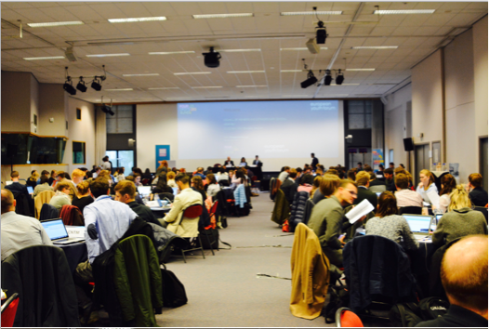
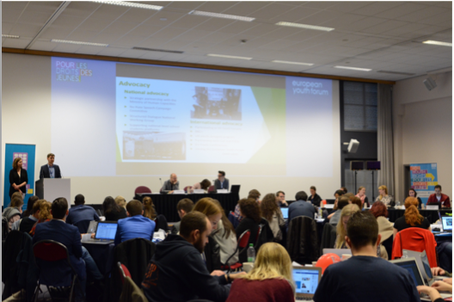

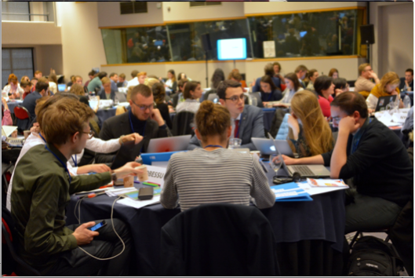

Working-Groups Rooms
In addition to the plenary room, 6-8 rooms:
- 35 people per room
- Beamer and possibility of sound system
- Flipcharts
These should only be reserved for the time necessary to hold these working groups– see agenda for details of schedule.
- Technical support
Beamer/-s in plenary:
- 3 beamers (1 for main projection, 1 for speech to text, 1 for twitter)
or
- 1 Beamer with a Di Ventix lense
or
- Option on how to divide the screen
- Technical table 3 seats (Ethernet cable) / Podium with 4-5 seats (2-3 microphones) / Table aside 11 (seats 7-8 microphones)
- Water fountains at the meeting room
- Sound system available
- Meeting should be recorded (original language)
- Translation booths
- Microphone at each table and four wireless microphones
- 200 plug connections
Interpretation Equipment
The translation equipment needs to be rented for the entire meeting for the plenary room. It is very important that the booths used by the interpreters are equipped with a door (otherwise the noise will disturb the interpreters and delegates), measure a minimum of 4-5m2. Depending on the nature of the venue, infra-red based equipment and wireless microphones are preferred.
It is essential that the interpretation equipment allow for recording of the full session, by the Forum’s Statutes.
The Forum is responsible for bringing the interpreters.
- Booths 4-5m2
- IR transmitters (+/-175)
- Opening (interpr. into native language)
Sign language and/or Speech to text translation
The Forum will provide sign language interpretation and/or speech to text if needed.
The sign language interpretation does not need any special facilities.
For the speech to text translation, we have interpreters with whom we work on a regular basis, and they have their own equipment. All that is needed is a screen on one side of the room.
This means concretely that we need three screens 1 main and bigger screen for presentations in the center behind the podium and possibly 1 screen on the left for then Speech-to-text.
Secretariat Room / Board Room / Info Desk
The Forum’s staff and the Board should have two separate working space near the plenary room, equipped:
- Big table or tables and chairs
- Internet access
- 1Flip chart
- 1Copy machine / printer / scanner (only Secretariat)
Info-Desk There should be a place next to the Plenary Room (a hall, for instance) where a Help- Desk can be settled, with two tables 3-4 chairs, 2 flipchart / notice boards.
- Non-smoking Policy
- Checking the non-smoking policy of the hotel important.
- Environmental policy
We would like to require no plastic containers (bottles, glasses...), during the meeting and keep it as much environmental friendly as possible. As it is commented on the meals section we would encourage using local, seasonal and if possible organic product on our meals. We are open to discuss all kind of possibilities.
Travel Arrangements & Visas
The host EYC will be responsible to ensure that delegates travelling from countries that require a visa in order to gain access to the host country are issued with an official invitation from the host EYC. This should be done as early as possible as it is sometimes a lengthy process to obtain such documentation from the competent authorities. The Forum will send all details of the people who require a visa to the host EYC, who will then in turn, send the visa request letter to the delegate directly. All subsequent contacts will be between the delegate and the host EYC.
Flights
The Youth Forum is not responsible for the organisation of the flights; delegates should be individually responsible for their own travel arrangements.
Volunteers
There is a need for generally 2 volunteers. However, more volunteers may be necessary to welcome people arriving at the airport and to direct them to the buses taking them to the hotel. The exact times & responsibilities will be forwarded when the internal working agenda is put in place.
Co-ordination
The co-ordination with the Forum is of crucial relevance for the organisation of the meeting. Therefore, having a clear identification of the responsible people and their role is very relevant. One of these people should be responsible for the co-ordination with the Forum Secretariat (Estefania Asorey, Rita Jonusaite for the European Youth Capital Award Ceremony) of all the technical details on the organisation of the meeting (hotel, meeting facilities, logistics, etc.).
General Issues
In case you have some questions, or you would like to check some issues, please, do not hesitate to call the main co-ordinator of the COMEM.
Social Programme
Saturday Night Social Evening
If possible, have a space at the hotel or town where delegates can socialize before to return to their countries.
European Youth Capital Award Ceremony
The European Youth Capital in question will host the upcoming European Youth Capital year. The European Youth Forum would like to celebrate such a special moment together with the EYC and create a unique ceremony. The ceremony will also provide space and time for announcing the European Youth Capital 2023.
The Award Ceremony is the event that gives an opportunity to introduce the host EYC to Member Organisations of the European Youth Forum and a wide rage of guests invited by the European Youth Forum and the Capital, It is a joint event that is designed together by the host EYC and the European Youth Forum.
Please find the list of technical aspects that should be taken into consideration regarding the organisation of the Award Ceremony. Regarding the co-creation of the programme (performances, speakers etc.), the European Youth Forum hopes for a constructive exchange of the ideas and suggestions with the host EYC.
The date
The Award Ceremony normally takes place an evening before the statutory meeting (COMEM) starts. The Award Ceremony in the host EYC usually takes place on the evening before the statutory meeting starts.
The venue
The venue should be able to accommodate at least 250 people. It is important to ensure that the venue is accessible for disabled people and complies with security requirements (fire, flood etc.). If the venue is not easily reachable on foot from the hotel (and back) where the European Youth Forum’s delegates are staying, the transportation should be provided. If possible seating arrangements would be welcomed.
Volunteers
There is a need for a number of volunteers to help to guide participants from their hotel to the venue of the Award Ceremony. The exact number and responsibilities shall be agreed when defining the agenda.
Moderation of the event
The event should be moderated either by international or local moderator ensuring translation if necessary.
Artistic performances
It is space for the host EYC to bring artists that can showcase the culture of the city, region or nation. The event is created together and it is important to give enough space and time for the host EYC. Hence, a number of performances e.g. by young local artists could be integrated in the programme of the Award Ceremony. If possible, the European Youth Forum would like to bring a solo or group from our Emerging Band Contest. Every year since 2010 we have a band contest for the YO! Fest, and the winners have a performance together with the headliner of the event. For example, Callum Steward, the singer at our Gala in April 2017 was one of the winners in 2017. This could be combined with the performance of a young local artist (s).
Guest to be invited
If possible, the European Youth Forum would like to invite previous EYCs to attend the Award Ceremony, notably the Mayors and high-level politicians, other people who contributed to the EYC year.
The Youth Forum and the host EYC should together invite all high-level attendees to the Council of Members and the Award Ceremony. Previous speakers have included European Commission’s Vice-President Jyrki Katainen for Jobs, Growth, Investment and Competitiveness, Commissioner for Education, Culture, Youth and Sport Tibor Navracsics, former Prime Minister of Romania Emil Boc. At least one high-level politician should be present at the European Youth Capital Award Ceremony on Wednesday night (suggestions include a Government Minister or Serbian Commissioner). During the GA, we can give some time for other high-level speakers, depending on their relevance.

The host EYC is welcome to invite any other guests it sees important to be present at the Award Ceremony.

Catering
Based on the space and a number of people the possibility of catering shall be discussed.

The space for the short-listed cities of the European Youth Capital 2023 competition
The event is called the Award Ceremony not without a reason. This is an important night for the cities running for the European Youth Capital 2023 title as the winner is announced during the Award Ceremony. The five shortlisted cities will come with their teams and supporters to celebrate the host EYC but also to get to know who will be awarded the title for 2023. Thus, it is important to ensure in the programme time and space for these cities to briefly present their applications to the audience.
Not an exhaustive list…
There is a number of things that should be also taken care of such as lights, audio, video, media presence, European Youth Capital and European Youth Forum visuals to be present etc. These are the aspects to be discussed during the preparation process and will not be detailed in this guiding document.
Deadlines
It is important to agree on the programme of the event a bit in advance in order to leave enough time for possible changes and rearrangements. The programme shall be finalized between the European Youth Forum and the host EYC by 1 November 2020.

Important to note
This is an event that is co-created by the host EYC and the European Youth Forum. Thus, both sides should exchange opinions, suggestions and together deliver the quality event that benefits the needs of both parties involved.

