Attn: Mayor of the Municipality of Klaipeda
30th June 2021

Dear Mr Mayor,

As you know in 2024 the Tall Ships Race will be sailed in the Baltic Sea and it promises to be yet another spectacular Tall Ships event attracting vessels and crews from around the world.

The Tall Ship Races is the biggest free family festival in Europe and each year attracts very high number of visitors to the Host Cities. Visitors at the Tall Ship Races are not only able to see, but also visit the spectacular fleet of 70+ vessels from around the world and interact with their captains and crews. The Event offers an opportunity for the local communities to participate in the festival; for local young people to experience sail training; and for local businesses and sponsors to actively engage with visitors and locals alike.

If the Municipality of Klaipeda wishes to be part of the Tall Ships Races 2024, we have agreed that you will be automatically accepted, without the need to present a formal bid. All that is required is that you confirm your intention by 30th June 2021, as stipulated on our Letter of Agreement dated 2nd June 2021 which you signed.

In attachment to this email you will find the following documents which will hopefully help you consider whether you would like to confirm your intention to host the Tall Ships Races 2024.

- Sample Host Port Contract
- Host Port Contract – Summary of Commitments
- Host Port Manual and Appendices

More information about Sail Training International can also be found on our website: www.sailtraininginternational.org and if you would like to discuss this letter in further detail, please do not hesitate to contact me.

If you have any queries on the TSR2024 planning process, please do not hesitate to contact me by email or telephone on the numbers below.

With kind regards,

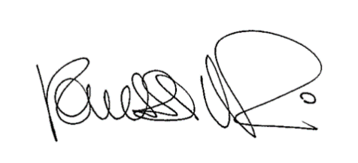

Vanessa Mori
Commercial Director

